Phase 9: Testing, QA & UAT

Prepared by: Kukkadapu Venkata Naga Vasudha Ramyasri

Phase 9 is dedicated to testing, quality assurance (QA), and user acceptance testing (UAT). This phase ensures that the Experience Cloud site is functioning correctly, meets requirements, and provides a secure, scalable, and user-friendly experience before final deployment.

**Step 1: Editing Page Properties**

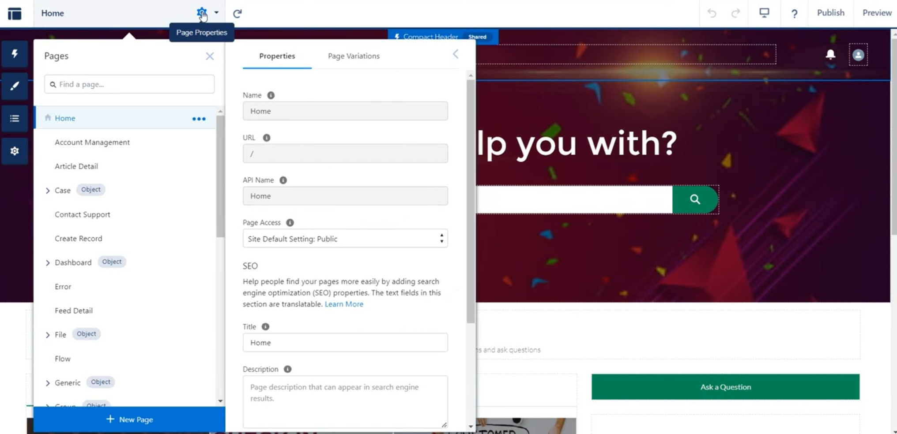

# Step 2: Editing Public Access

# 

# Step 3: Changing Visibility Settings

# 